Username : nagarajsv3bu@gmail.com

Password : Sb@01

**IAM - Identity Access Management**

**https://117349099179.signin.aws.amazon.com/console**

https://nagarajsv3bu.signin.aws.amazon.com/console

AWS Account : **117349099179**

IAM is universal.

root account - aws account - has complete admin access.

New Users has **No Permissions** when they are created.

New Users are assigned **Access Key ID** and **Secret Access Key** when they are created.

We can use **Access Key ID** and **Secret Access Key to access AWS via APIs and CLI.**

We can use **Username and Password to login to AWS Console.**

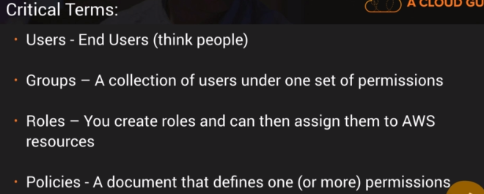

**Amazon Compute Cloud (EC2) : EC2 is basically a Virtual Machine in the Cloud**

**EC2 options**

1. On Demand

2. Reserved

3. Spot : If spot instances are terminated by Amazon, then users are not charged for the partial hour.

4.Dedicated Hosts

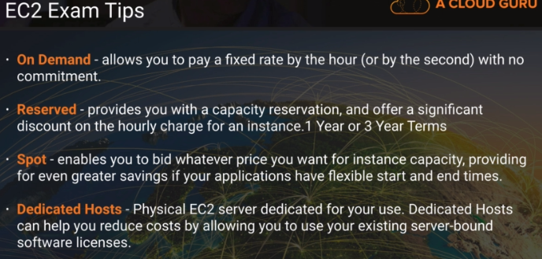

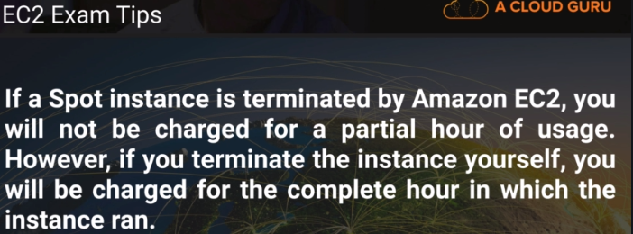



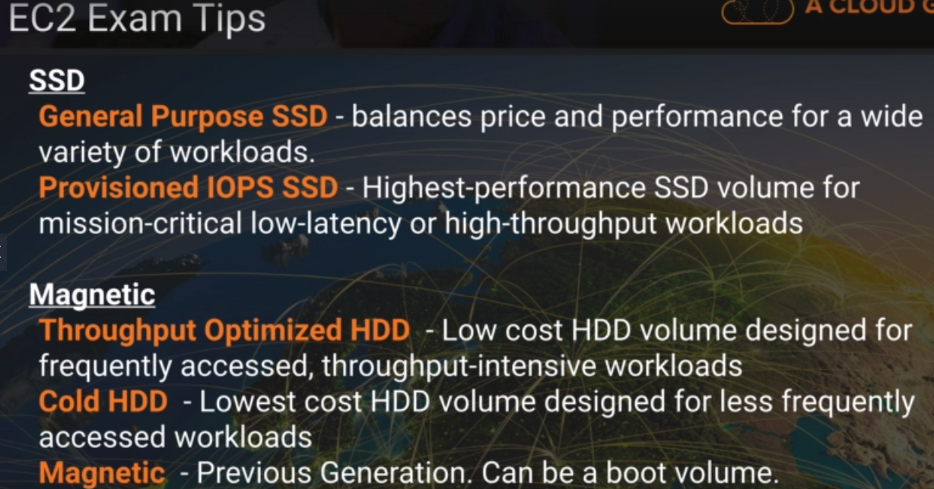

**EC2 Instance Types**

**FIGHT DR MC PX**

**Amazon EBS : Elastic Block Storage : Virtual Disk in Cloud**

**EBS Volume Types**

**SSD**

1. General Purpose SSD (GP2) - Upto 10000 IOPS

2. Provisioned IOPS SSD (IO1) - If you need more than 10000 IOPS

Upto 20000 IOPS

Needed for high performance intensive applications such relational and no sql databases

**Magnetic**

1. Throughput optimized HDD (ST1) - **Bigdata & cannot be a boot value**

BigData, Dataware house, Log processing

2. Cold HDD (SC1) - Lowest Cost storage

File Server

Cann't be a boot volume

**3. Magnetic (Standard) - Bootable & Lowest Cost**

**EC2**

**Network - VPC - Virtual Data Center**

Putty (ssh & telnet client) to ssh into ec2 instance

puttygenkey (RSA & DSA key generator)

**keypair is in .pem format**

Convert pem files to ppk files using puttygenkey

1. elavate user permission to root using

**sudo su**

2. convert a unix server to web server

**yum update -y**

3. install apache

**yum install httpd**

4. start apache service

**service httpd start**

5. automatically bootstrap apache if ec2 is restarted

**chkconfig httpd on**

6. check apache status

**service httpd status**

**7.** change directory

**cd /var/www/html**

8. create index.html

**nano index.html**

**Elastic Load Balancer**

**Types of Load Balancer**

1. Application Load Balancer : Operates at OSI Layer 7 : Load balancing of http & https traffic

2. Network Load Balancer : Operates at OSI Layer 4 : Load Balancing of TCP traffic

3. Classic Load Balancer : Legacy Elastic Load Balancer

We can do either Layer 7 or Layer 4 load balancing using Classic Load Balancer

Classic Load Balancer responds with 504 error if application stops (issue with webservice layer or database layer) responding.

When Elastic Load Balancer calls Ec2 instance, public ipv4(ip) (end user ip) address is stored in x-forwarded-for header.

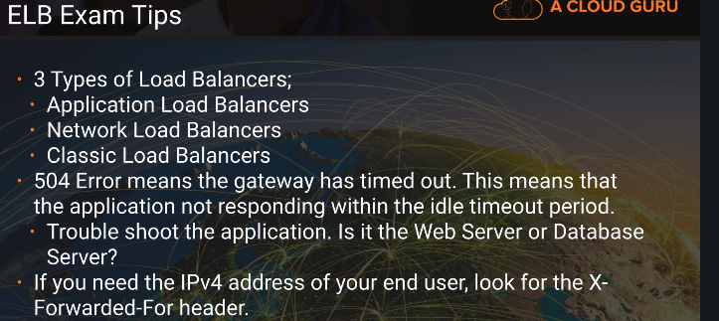

Layer 7 features :

1. X-Forwarded

2. Sticky sessions

**Route53 - Amazon's DNS Service**

Allows us to map your domain name(such as cloudguru.com) to

1. EC2

2. Load Balancer

3. S3 Buckets

Domain -> Load Balancer -> EC2 Instance

**CLI**

**aws s3 ls**

**aws configure**

Make a bucket - mb

**aws s3 mb s3://naga1234-nsv**

**aws s3 ls**

Upload to s3 bucket

**aws s3 cp hello.txt s3://naga1234-nsv**

list a bucket

**aws s3 ls s3://naga1234-nsv**

**CLI Tips**

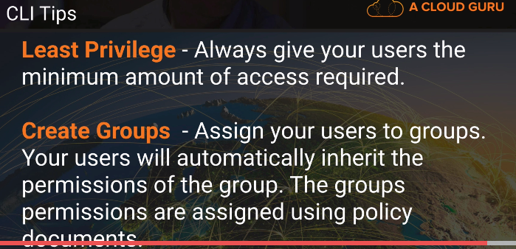

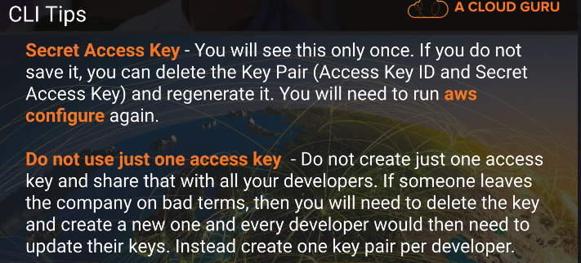

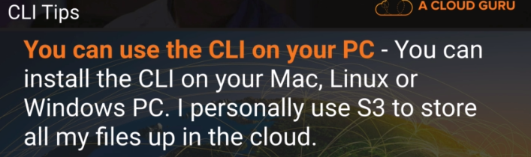

**EC2 with S3 Roles**

**cd ~/.aws**

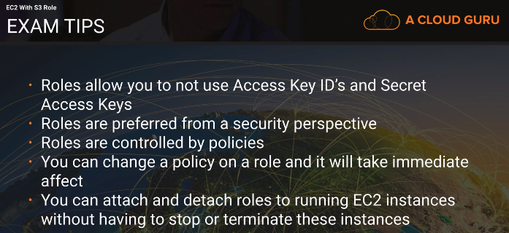

**RDS - Relational Database Service - OLTP**

**Relation Database types**

1.SQL Server

2.Oracle

3.MySql Server

4.PostgreSQL

5.Amazon Aurora

6.MariaDB

**NonRelational DB/ NoSQL DB :** We dont need predefine the table structure

Amazon Dynamo DB

Database

Collection = Table

Document = Row

Key-Value Pair = Fields

**Data Warehousing**

Business Intelligence

**Business Intelligence Tools :**

Cognos

Jaspersoft

Sql Server Reporting

Oracle Hyperion

Sap netweaver

OLTP vs OLAP

OLTP - Online Transaction Processing

OLAP - Online Analytics Processing

OLAP - Redshift - Amazon's Online Analytics Processing

**Elasti Cache :** In memory cache in the cloud

Open In-Memory Cache Engines that Elasti Cache suports

1.Memcached

2.Redis

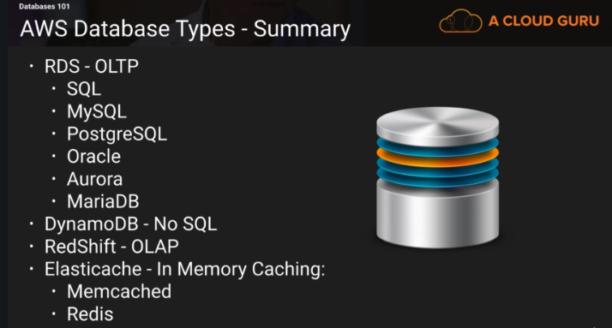

**EC2 in one Security group able to connect to RDS in another security group. How ?**

Open Up Port 3306 for the security where RDS instance is in, to the security group where your EC2 instance is in.

**Backups**

1. Automated Backups

2. Database snapshots

**Automated Backups**

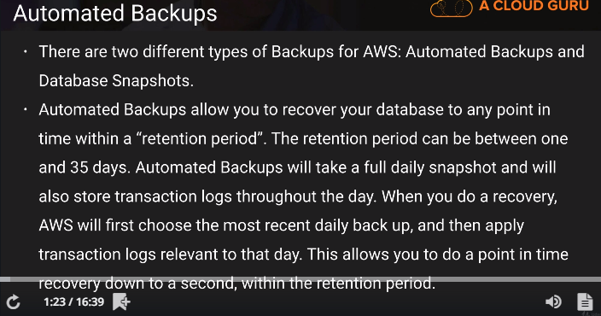

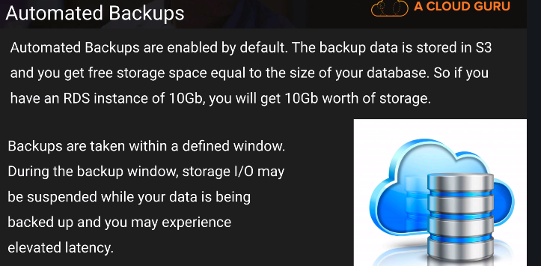

**DB Snapshots**

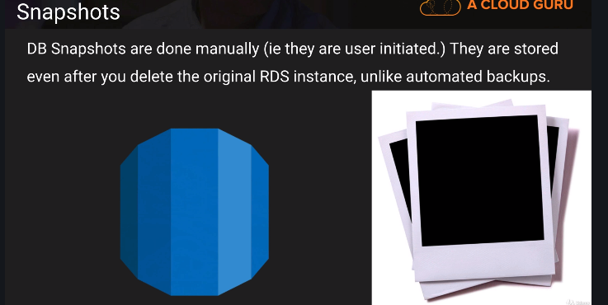

If original RDS instance is deleted, then Automated Backup gets deleted too; but not the DB snapshots.

**Restoring Backups**

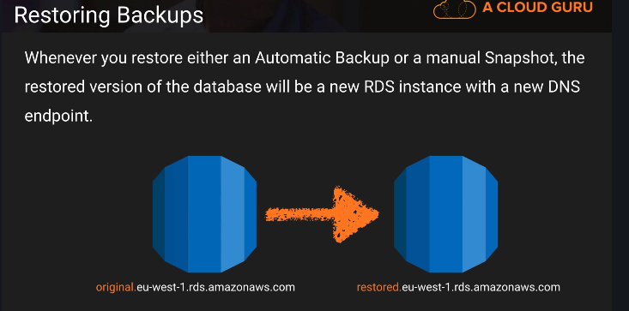

**Encryption**

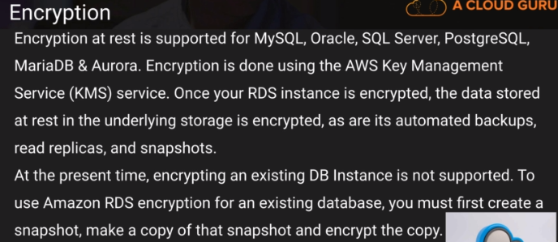

**Multi-AZ RDS**

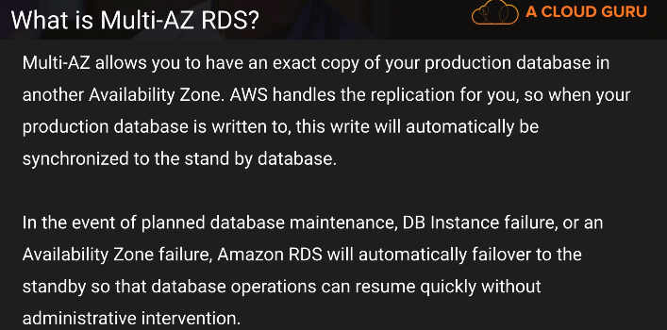

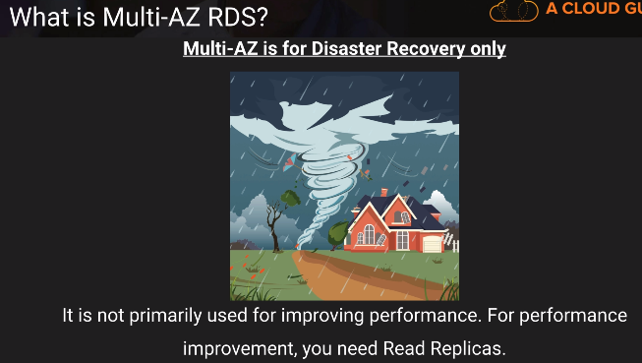

**Multi AZ - Synchronous - Disaster Recovery**

**Read Replicas - Asynchronous - Performance Improvement**

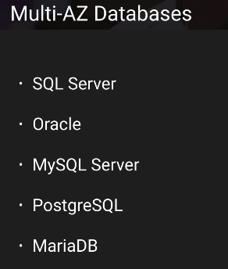

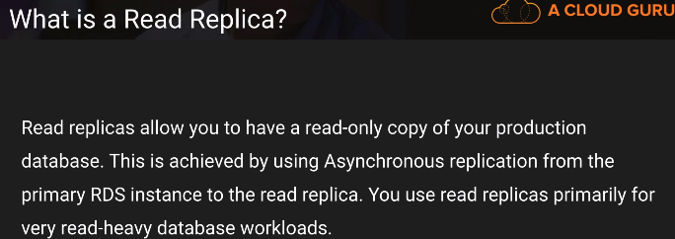

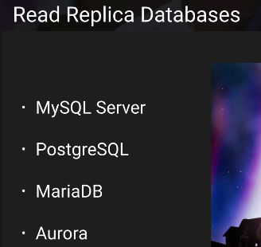

**Read Replica Databases are not available for Oracle and Sql server**

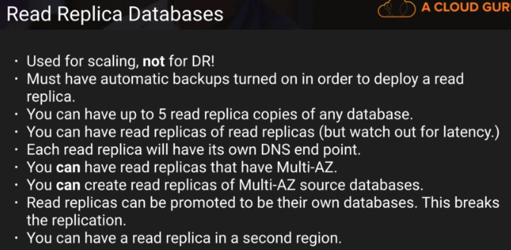

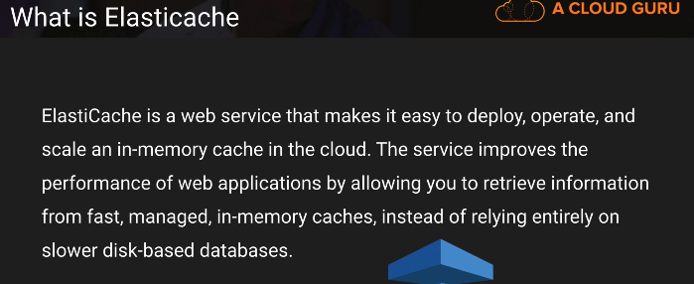

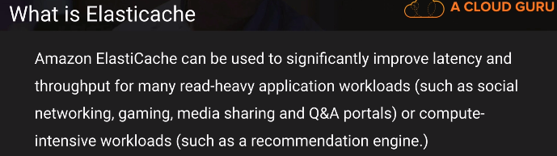

**MemCached :** Memory Object Caching System : Pure Caching System with no persistence and replication

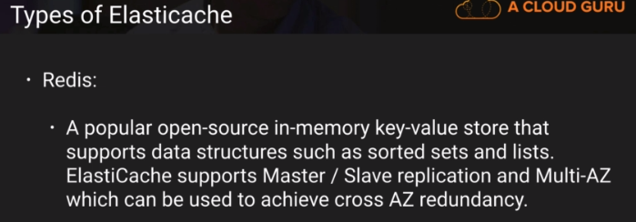

**Redis : Persistence and Replication and Sorting and Collections**

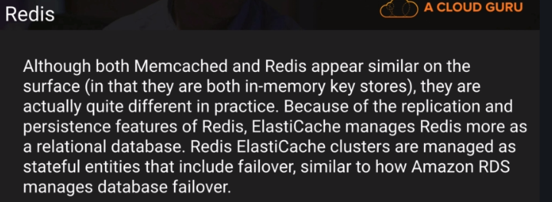

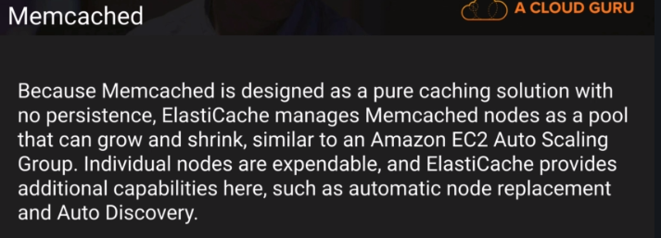

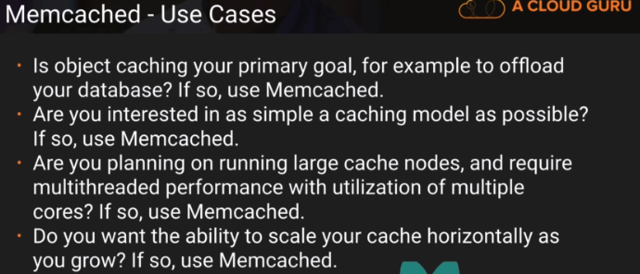

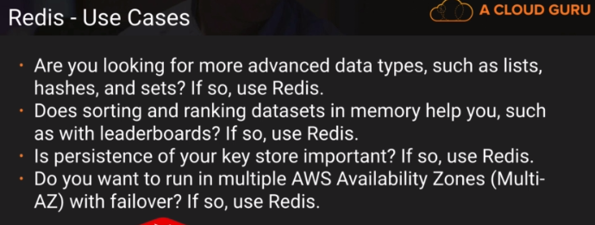

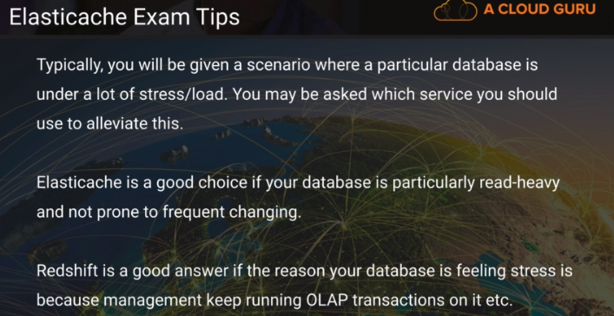

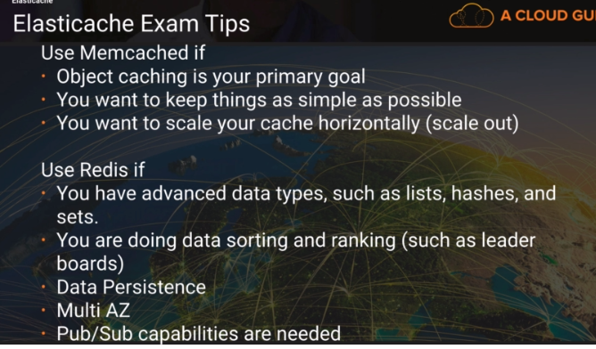

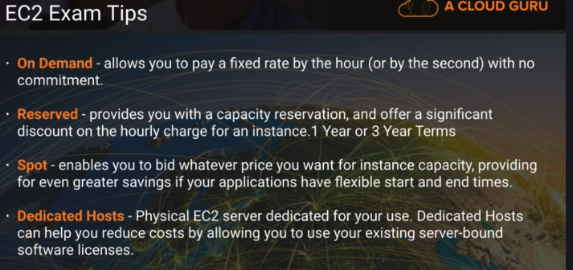

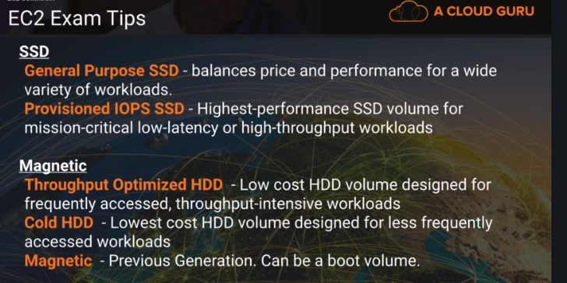

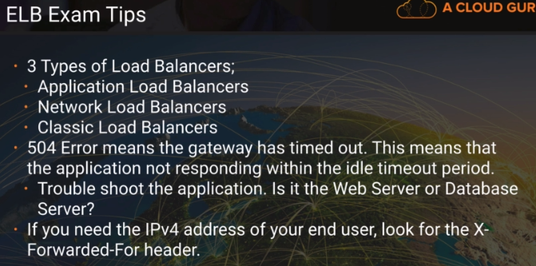

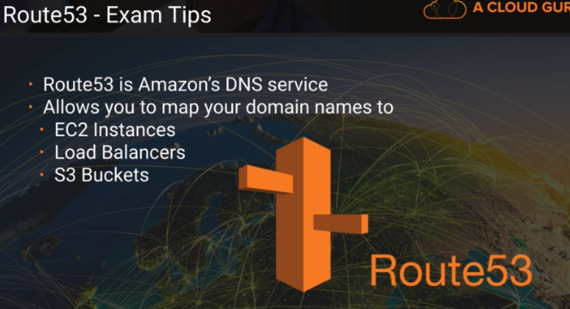

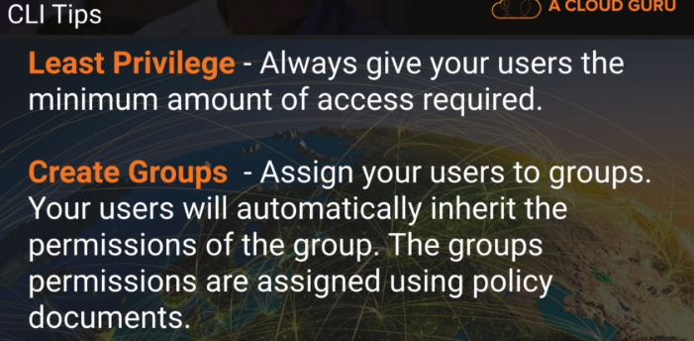

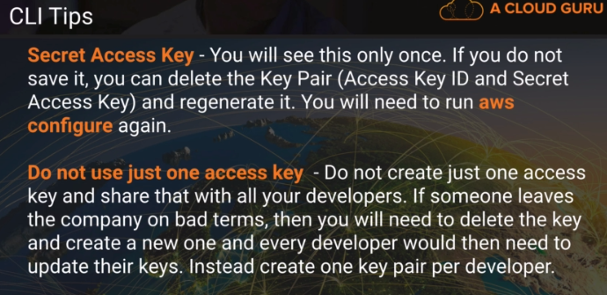

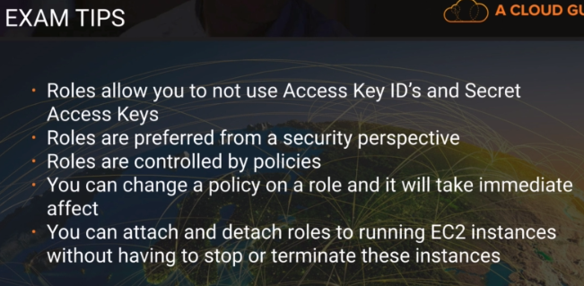

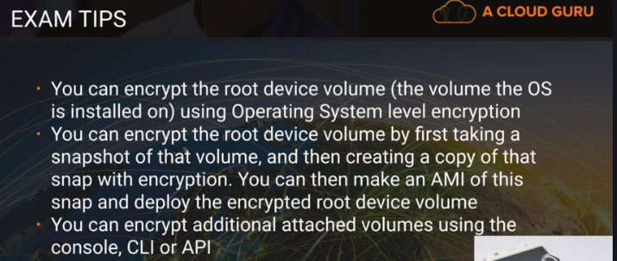

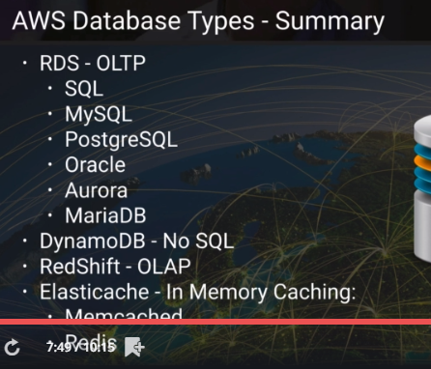

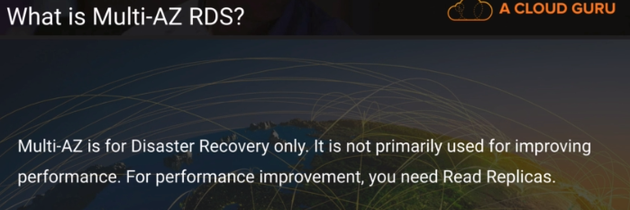

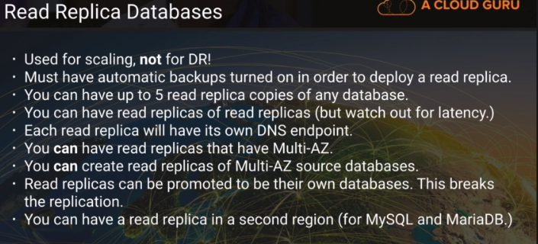

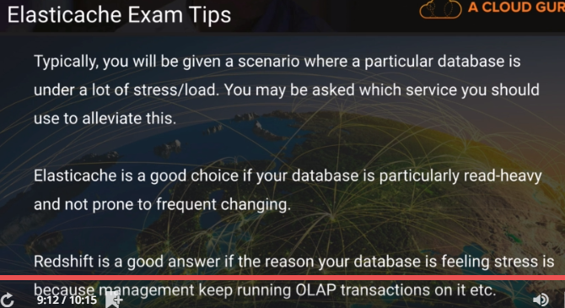

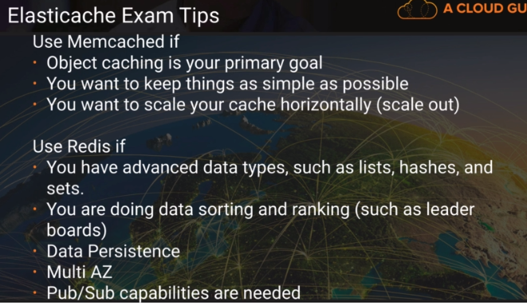

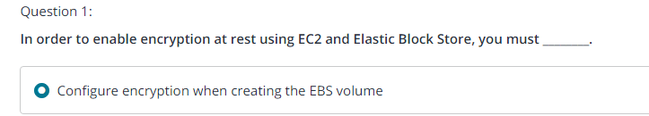

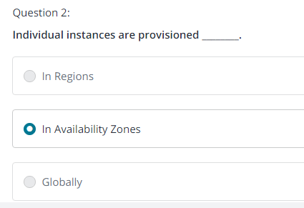

**S3 - Simple Storage Service**

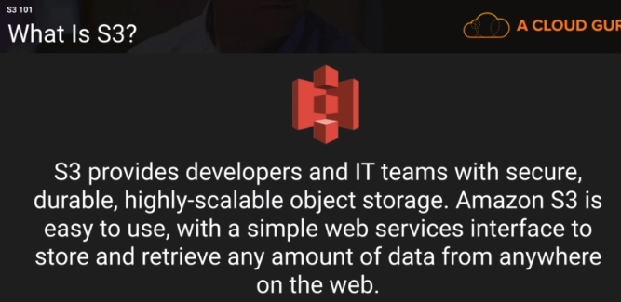

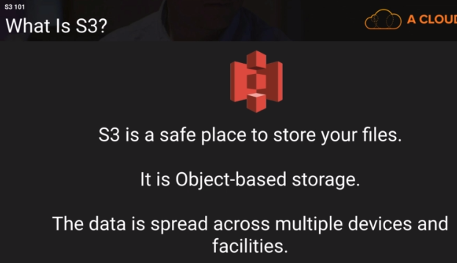

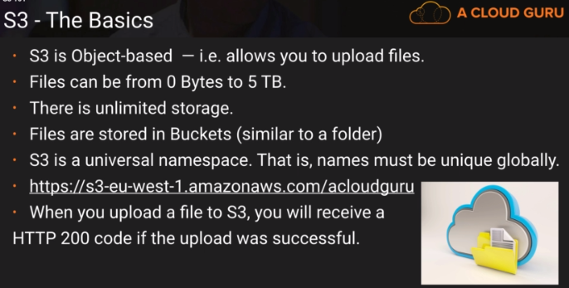

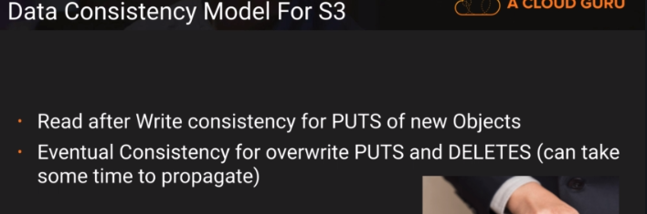

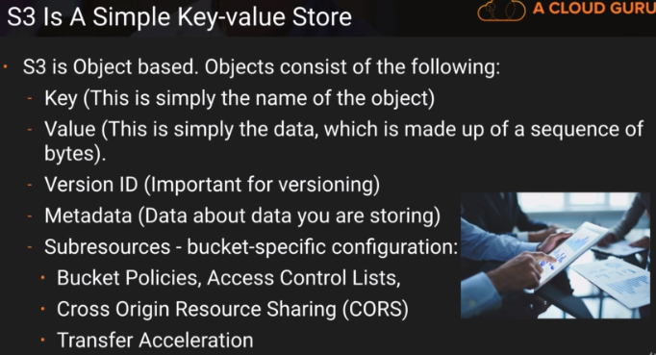

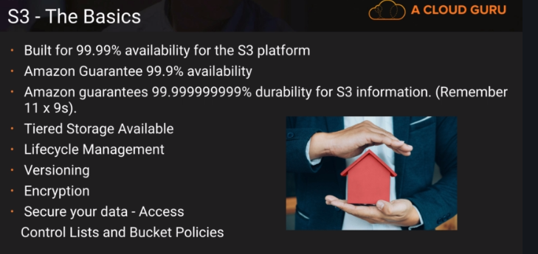

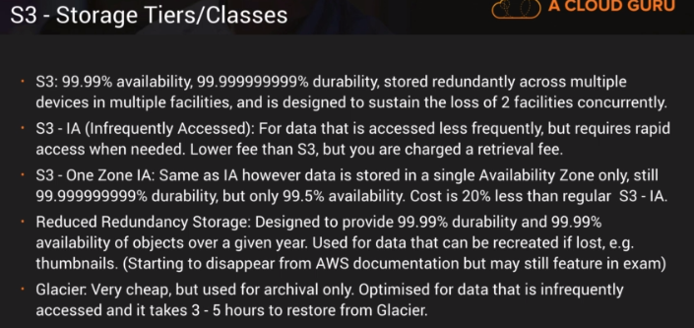

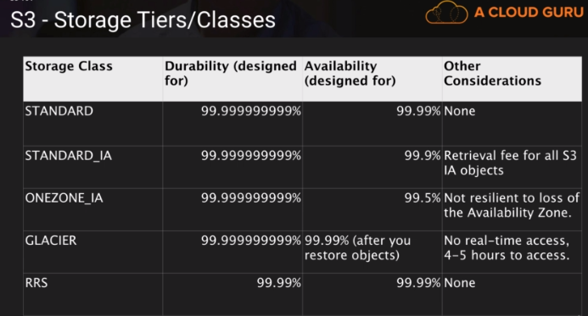

**Important :**

**IAM - Provides Security**

**EC2 - Virtual Server in Cloud**

**EBS - Virtual Disk in Cloud**

**ELB - Elastic Load Balancer**

**Route53 - Amazon's DNS Service**

**RDS - RelationalDatabase Server**

**Aurora DB- Amazon Relational Database server**

**Dynamo DB - Amazon Non Relational Database**

**Redshift - Amazon's online analytics processing - OLAP**

**S3 - Simple Storage Service**